October 1, 2014
2014-134 File: BA-18

BRITISH AIRWAYS UPDATE

There is a document circulating at all stations called “Implementation Support” and that document is asking for volunteers to train the GHA staff at the seven locations British Airways has decided to outsource.

After over two and one half years of difficult negotiations that included the outsourcing of seven stations and the loss of over 120 of our colleagues, co-workers and brothers and sisters livelihoods, at the insistence of our employer, British Airways, the Company is now looking for volunteers to train their replacements.

Your negotiating committee explored every option to keep those stations staffed with our own employees but at every turn the answer was No.

It is unconscionable that the Company would now be soliciting volunteers to train the replacement work force. This is a time when as union members we should be uniting and not disrespecting the legacy of our colleagues and coworkers by volunteering to go to their former station and assisting in training their low wage replacements.

The Union position is that no employee from any of the remaining ten staffed stations should be volunteering to assist in the training of the GHA staff at the seven outsourced locations.

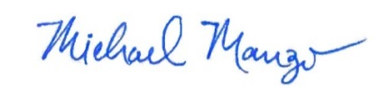
Fraternally yours,

Michael Manzo
GENERAL CHAIR

John Reisert Reggie Gauthier Harvey Berman
NEGOTIATING COMMITTEE MEMBERS
MM/slb
cc: S. Pantoja
J. Tiberi
T. Klima
I. Levy
142 Executive Board
opeiu #320
POST ON ALL IAM BULLETIN BOARDS

