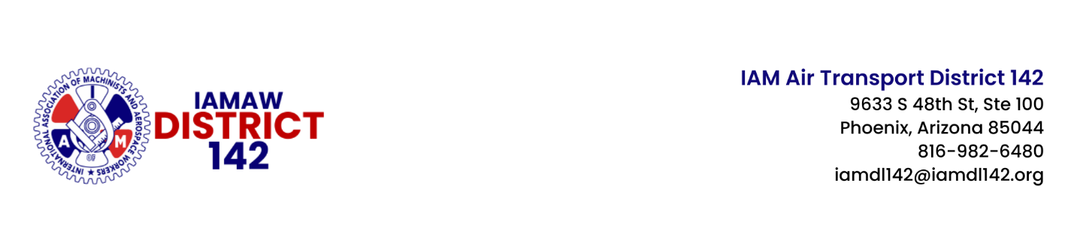
Date: September 17, 2023
File: Signature - 2023
2023 – 93

IAM/SIGNATURE FLIGHT SUPPORT MDW NEGOTIATIONS UPDATE:
TENTATIVE AGREEMENT REACHED

Dear Sisters and Brothers:

IAM District 142 has reached a Tentative Agreement with Signature Flight Support MDW. The new agreement includes:

- Enhanced Mandatory Overtime Rules adding protections and enhanced rates of pay.
- Adjustments to the Sick Policy.
- Substantial Increases to base rates of pay, shift differentials, and premiums.
- Improved Holiday language.
- All improvements, enhancements, and increases are fully retroactive to June 11, 2023.
The Tentative Agreement, with changes marked in red, is available online at the DL 142 website, https://atd142.org. General Chair Bill Wise will be on the property on Tuesday, September 19, 2023, to answer questions about the agreement. The ratification vote will be held on Wednesday, September 20, 2023, from 9:00 a.m. to 5:00 p.m. CDT in the Signature Flight Support MDW Conference Room.

We would like to take this opportunity to thank Carlos Flores, Bernard Phillips, and Justin Dominiak for the time, energy, dedication, and professionalism they put into these negotiations. We would also like to thank the membership for your patience and solidarity. Your negotiating committee unanimously recommends a YES VOTE for this agreement.

Sincerely and fraternally,

John M. Coveny, Jr.
President/Directing General Chair
IAM District 142

Bill Wise
General Chair
IAM District 142

JMC/BW/td

cc: R. Johnsen, General Vice-President, Air Transport Territory
E. Fraser, Chief of Staff, Air Transport Territory
T. Regan, Airline Coordinator, Air Transport Territory
DL 142 Executive Board

POST ON ALL IAM BULLETIN BOARDS

