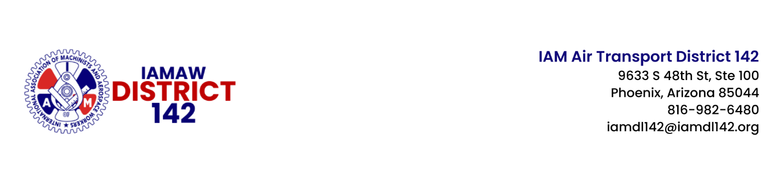
Date: September 6, 2024
File: SIGNATURE IAD – 2024
2024 – 110

IAM/SIGNATURE FLIGHT SUPPORT IAD CALL FOR CONTRACT PROPOSALS

Dear Sisters and Brothers:

Your IAM District 142 negotiations team is preparing to begin negotiations with Signature Flight Support for your Collective Bargaining Agreement (CBA). One of the first steps in this process is the official Call for Contract Proposals.

Submitting contract proposals is your way of being directly involved in negotiating your contract. By telling your negotiations committee precisely what you want or don’t want in your contract, you will enable them to negotiate effectively, and most importantly, it empowers you by giving you a voice at the table.

The IAM/Signature Flight Support IAD Contract Proposal Form is online and can be accessed by the QR Code or link below.

 | https://bit.ly/atd142-SFS-IAD-Proposal-Form

If you wish to submit multiple proposals, please fill out a separate form for each proposal. The deadline is September 14, 2024. Once submitted, your negotiating committee will collect and review these proposals, which will help direct the direction and pace of negotiations.

Once the union and the company agree on a negotiation schedule, we will keep you updated on the progress. Our goal is to bring you a Tentative Agreement that you will be proud to vote YES for.

Don't hesitate to contact your General Chair, Bill Wise, at bwise@iamdl142.org with any questions or concerns. Your continued support and solidarity are needed throughout this process.

Sincerely and fraternally,

John M. Coveny, Jr. Bill Wise
President/Directing General Chair General Chair
IAM District 142 IAM District 142

JMC/BW/td

cc: | R. Johnsen, General Vice-President, Air Transport Territory
 | E. Fraser, Chief of Staff, Air Transport Territory
T. Regan, Airline Coordinator, Air Transport Territory
J. Carlson, Air Transport Coordinator
 | DL 142 Executive Board
POST ON ALL IAM BULLETIN BOARDS

