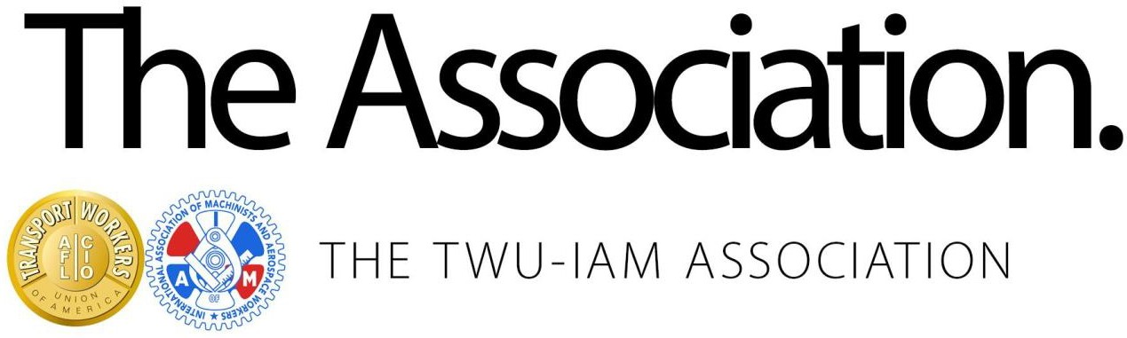
October 21, 2024

Re: American Airlines Contract Extension Vote

TWU-IAM Association Brothers and Sisters:

After working with BallotPoint Election Services company, the following schedule for the voting process for the American Airlines Economic Extensions to each eligible voting member has been finalized.
Paper ballots were mailed out via USPS today, October 21, 2024. The Economic Extension email ballot notification packets will be sent from BallotPoint Election Services to your individual @aa.com email addresses on Friday, October 25th, 2024 shortly before the voting window opens. Votes may be cast via internet or phone.
The window for voting on your American Airlines Economic Extension will start on Friday October 25th, 2024 at 12:00 (noon) Central Time and will end on Tuesday October 29th, 2024 at 12:00 (noon) Central Time.

Fraternally,

The TWU-IAM Association Leadership

