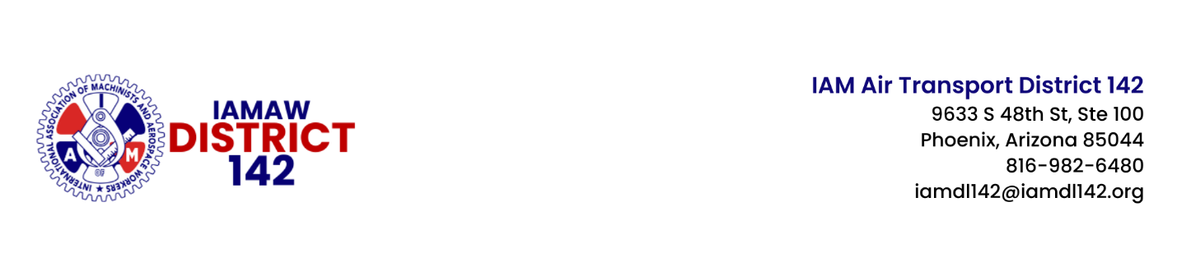
Date: April 18, 2025
File: OH – 2025
2025 – 54

DISTRICT 142 NEGOTIATING COMMITTEE FOR PSA STORES ATTENDS NEGOTIATION PREP CLASS AT THE WINPISINGER CENTER

Dear Sisters and Brothers:

Your IAM District 142 Negotiating Committee for PSA Stores convened at the IAM’s William W. Winpisinger Education & Technology Center in Hollywood, MD, during the week of April 12 for a Negotiations Prep course. This course was designed to teach our new team members the fundamentals of negotiation.

The week-long training included classroom instruction, practicing proposal writing, and cost analysis to justify proposals. Our team also participated in a mock negotiation session. Using the knowledge and new techniques learned this week will better prepare our team when we finally sit down face-to-face with PSA to negotiate the best contract possible for our membership.

We will continue to prepare using virtual Zoom calls with our team to write our proposals. District 142 has agreed to facilitate a full week at our headquarters in Phoenix, AZ, the week of May 19, so we can work face-to-face as a team.

Please continue to support your negotiating committee as they continue writing proposals and then move into the critical phase of direct negotiations. Thank you for your patience and solidarity.

Sincerely and fraternally,

John M. Coveny, Jr., Ken Coley Todd Roan
President/Directing General Chair General Chair Acting General Chair/VP

Negotiating Committee:

Rich Jones – DAY Michelle Guida – CLT Brittany Brigham - DFW

JMC/et al/td

cc: | R. Johnsen, General Vice-President, Air Transport Territory
 | E. Fraser, Chief of Staff, Air Transport Territory
T. Regan, Airline Coordinator, Air Transport Territory
J. Carlson, Air Transport Coordinator
 | D142 Executive Board

POST ON ALL IAM BULLETIN BOARDS

